Green Star School Certification – Step 3 (Project Timeline)
By Girl Scout Troop 61563

Spring 2018

Girl Scouts from Troop 61563 (in the OSS 4/5 classrooms) ran an audit of the bins in the cafeteria at Ocean Shore School. They found significant contamination across bins: OSS students use the recycling and landfill buckets interchangeably and food waste (eaten and uneaten organic material) is deposited in all three buckets.

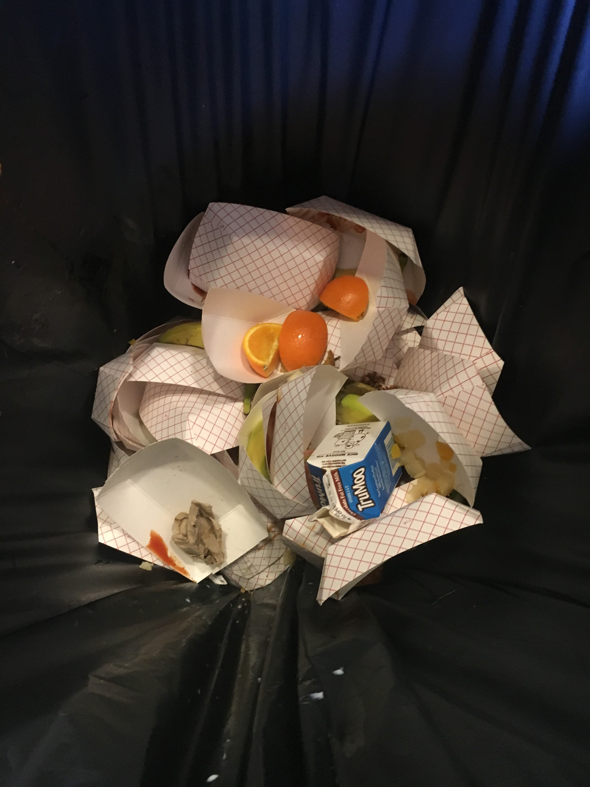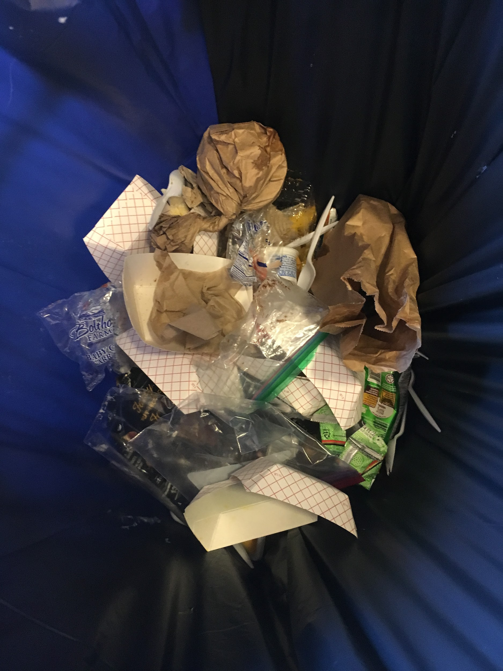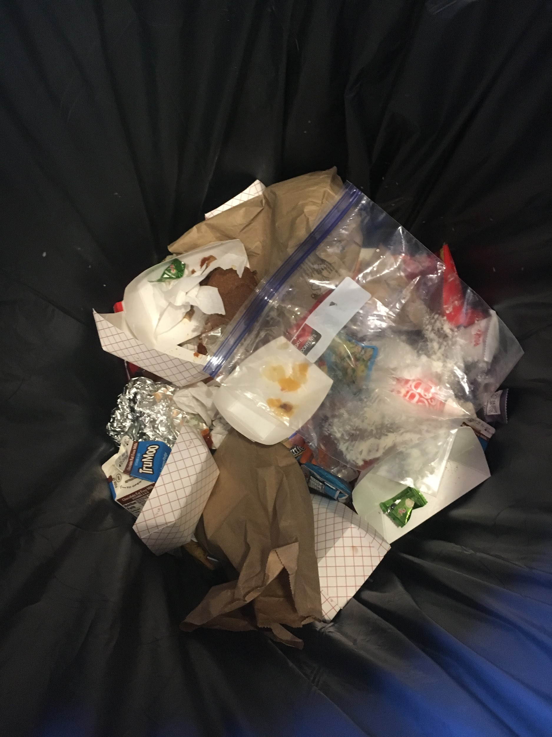
OSS cafeteria bins at the end of lunch.
Spot the difference! Can you tell which is Landfill, Recycling and Compost?

The scouts brought their findings to the OSS staff, asking for permission to take the following action in the cafeteria:
- Start a Share Table to recycle uneaten food.
- Reorganize cafeteria bins and dismissal process at the end of lunches to reduce bin contamination.
- Compost food scraps.
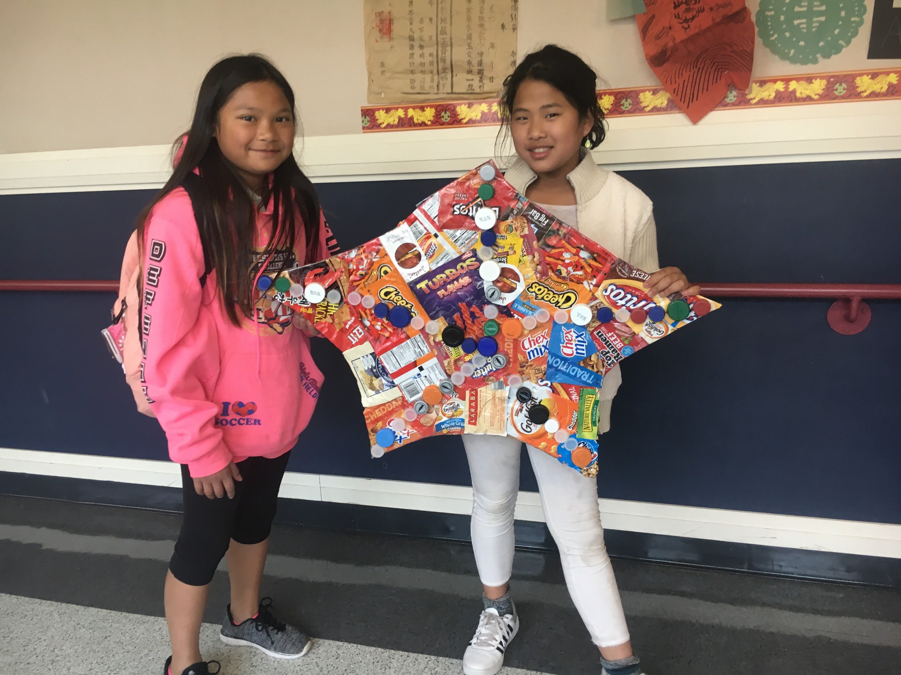
Wrapper Art, demonstrating the variety of single-use food item wrappers
collected at the end of lunch in the OSS cafeteria.

OSS staff approved a compost pilot study to collect data for Jennifer Werkstatt’s 4Rs Grant-funded garden composting project. During Earth Week, the troop collected students’ food scraps and salad bar leftovers to determine the volume of “clean greens” available for composting in the garden.

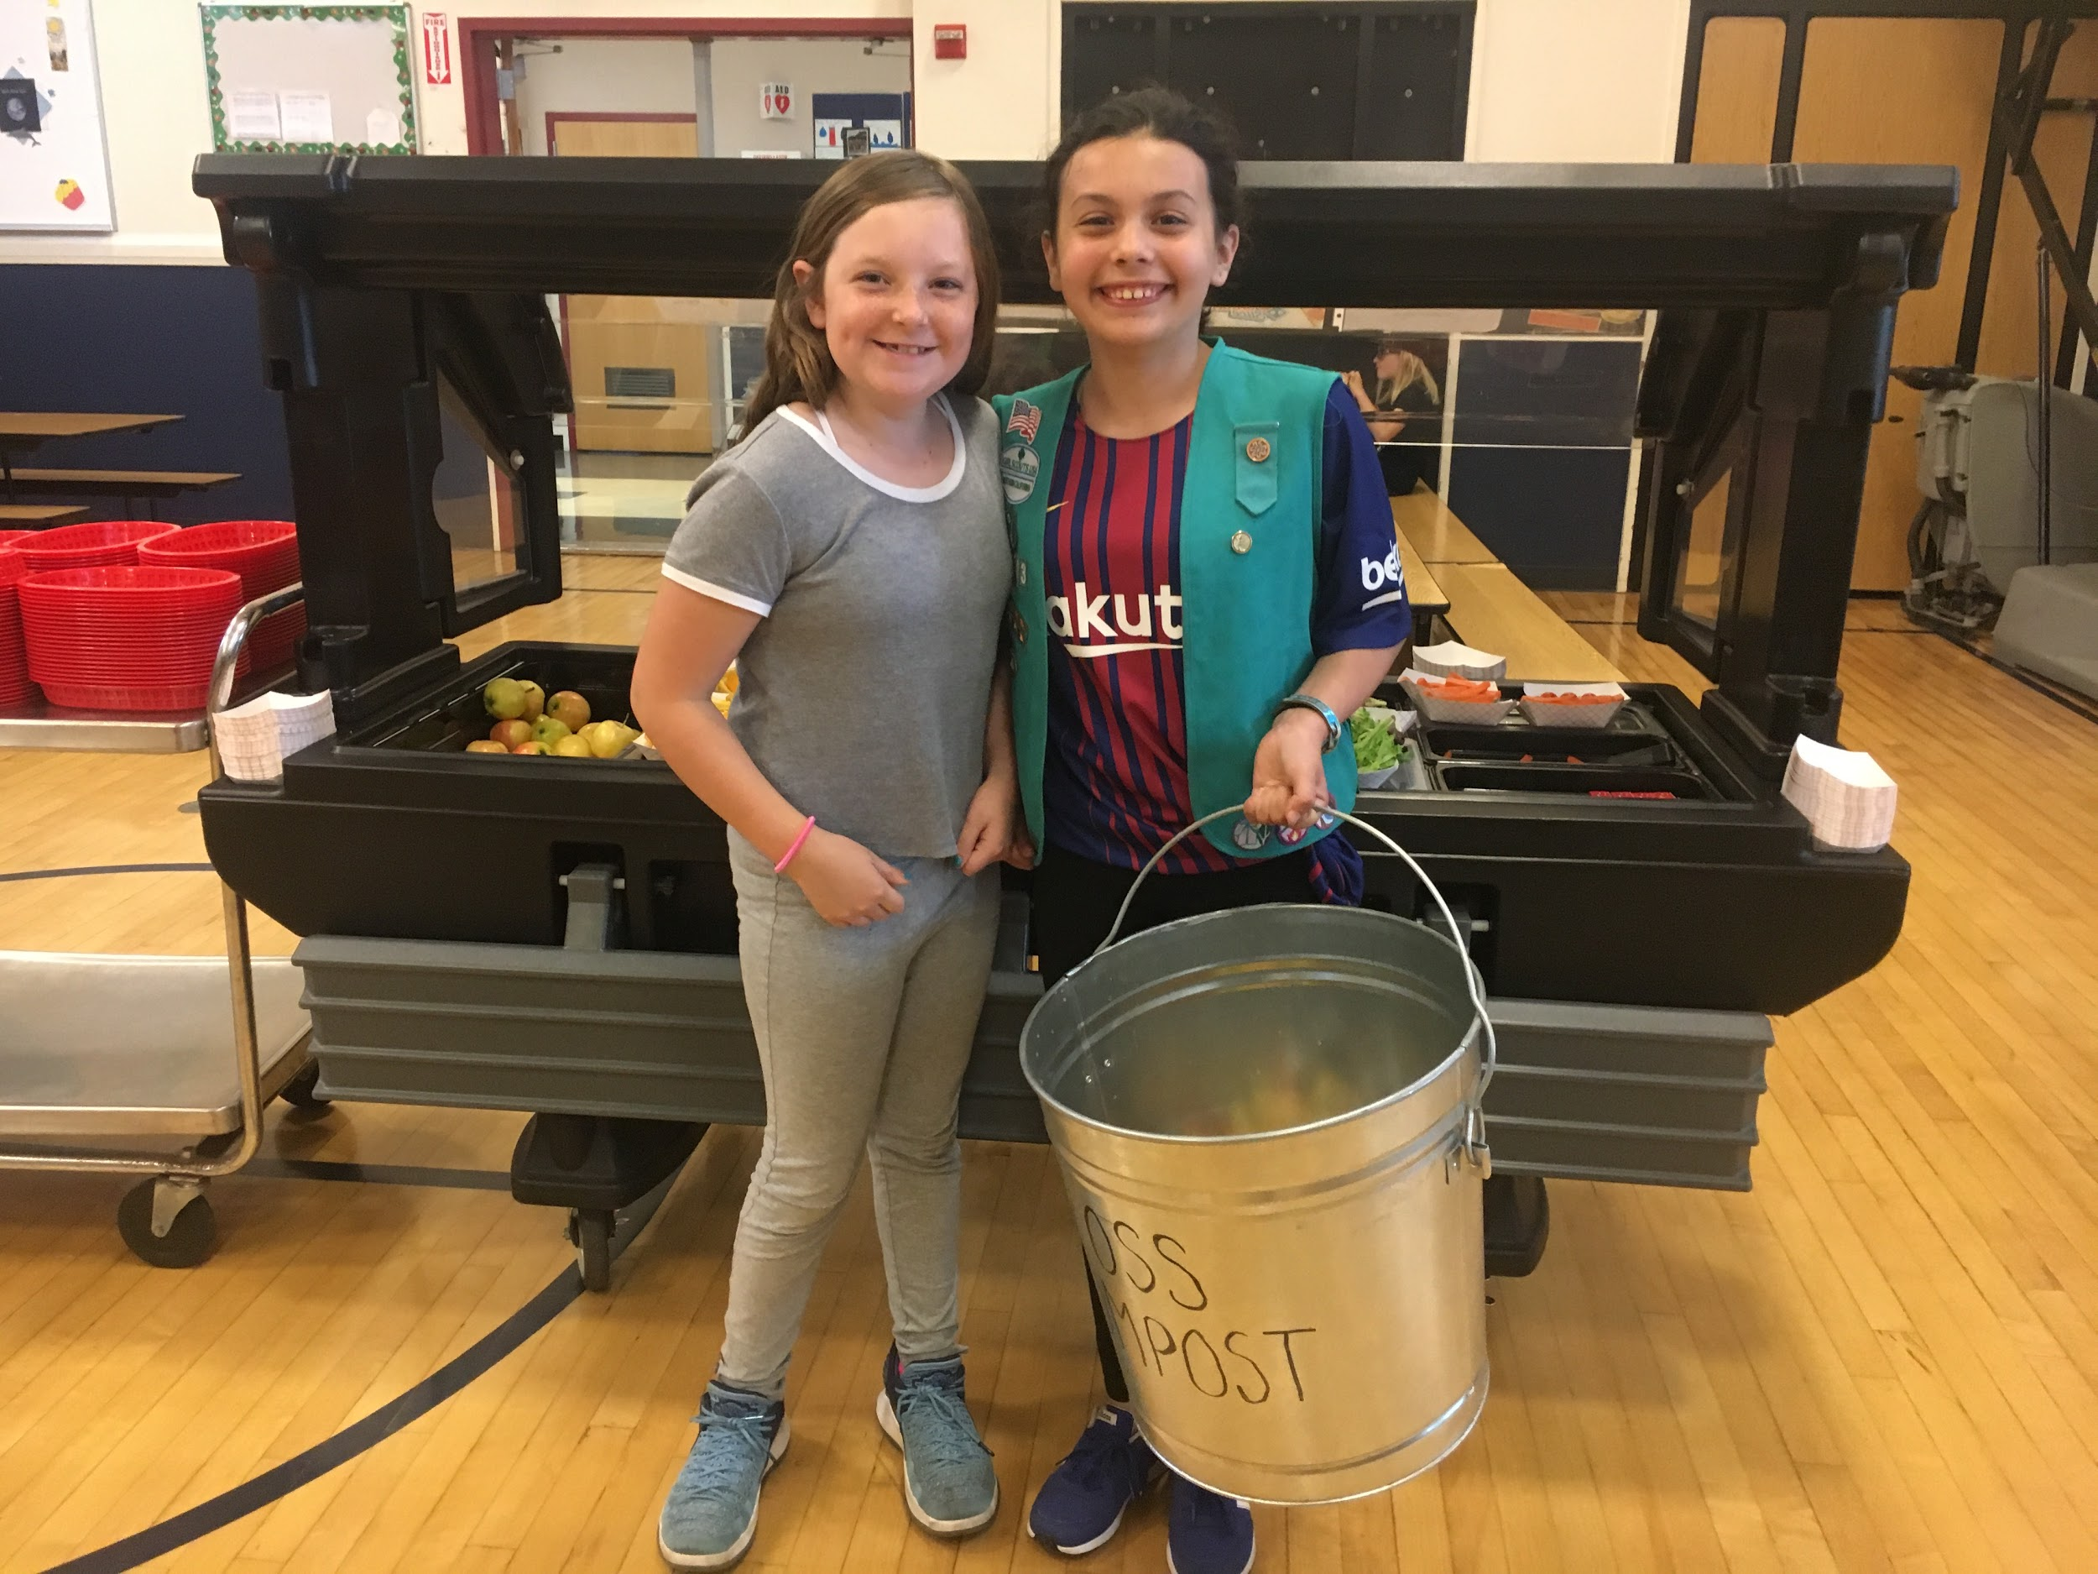
Collection of clean greens from the salad bar.

Results of composting test run:
- Day 1: 5 pounds (collected from 2 lunches)
- Day 2: 3 pounds (collected from 1 lunch)
- Day 3: 14 pounds (collected from 2 lunches plus leftovers from the salad bar)
- Day 4: 8 pounds (collected from 2 lunches plus leftovers from the salad bar)

A detailed summary / slide show of this phase of work is available upon request. It provides information about a variety of findings, including the types of food thrown away at the end of each lunch, the sources of landfill collected, and the troop’s discovery of how plastic drinking straws were entering the OSS cafeteria!

Fall 2018

The scouts and EAT members revisited goals from the prior school year.

-Food sharing.
A team of San Mateo County Health representatives came to OSS to present their new Food Share program. At this time (October 2018), OSS was ready to implement the program, but the district denied the request, expressing concern about the risk of allergies and food sharing.

-Improving bin use.
After discussing several proposals for reorganizing the cafeteria bins and introducing a new “clean greens” bin and/or changing the student dismissal procedures, the kitchen and custodial staff decided to stick with the existing system, but they allowed Troop 61563 to begin collecting salad bar leftovers at the end of the 6-8 lunch.

-Composting.
With this source of clean greens, the scouts learned to use the new three-bin composting system in the OSS garden and began filling the first bin three times/week.

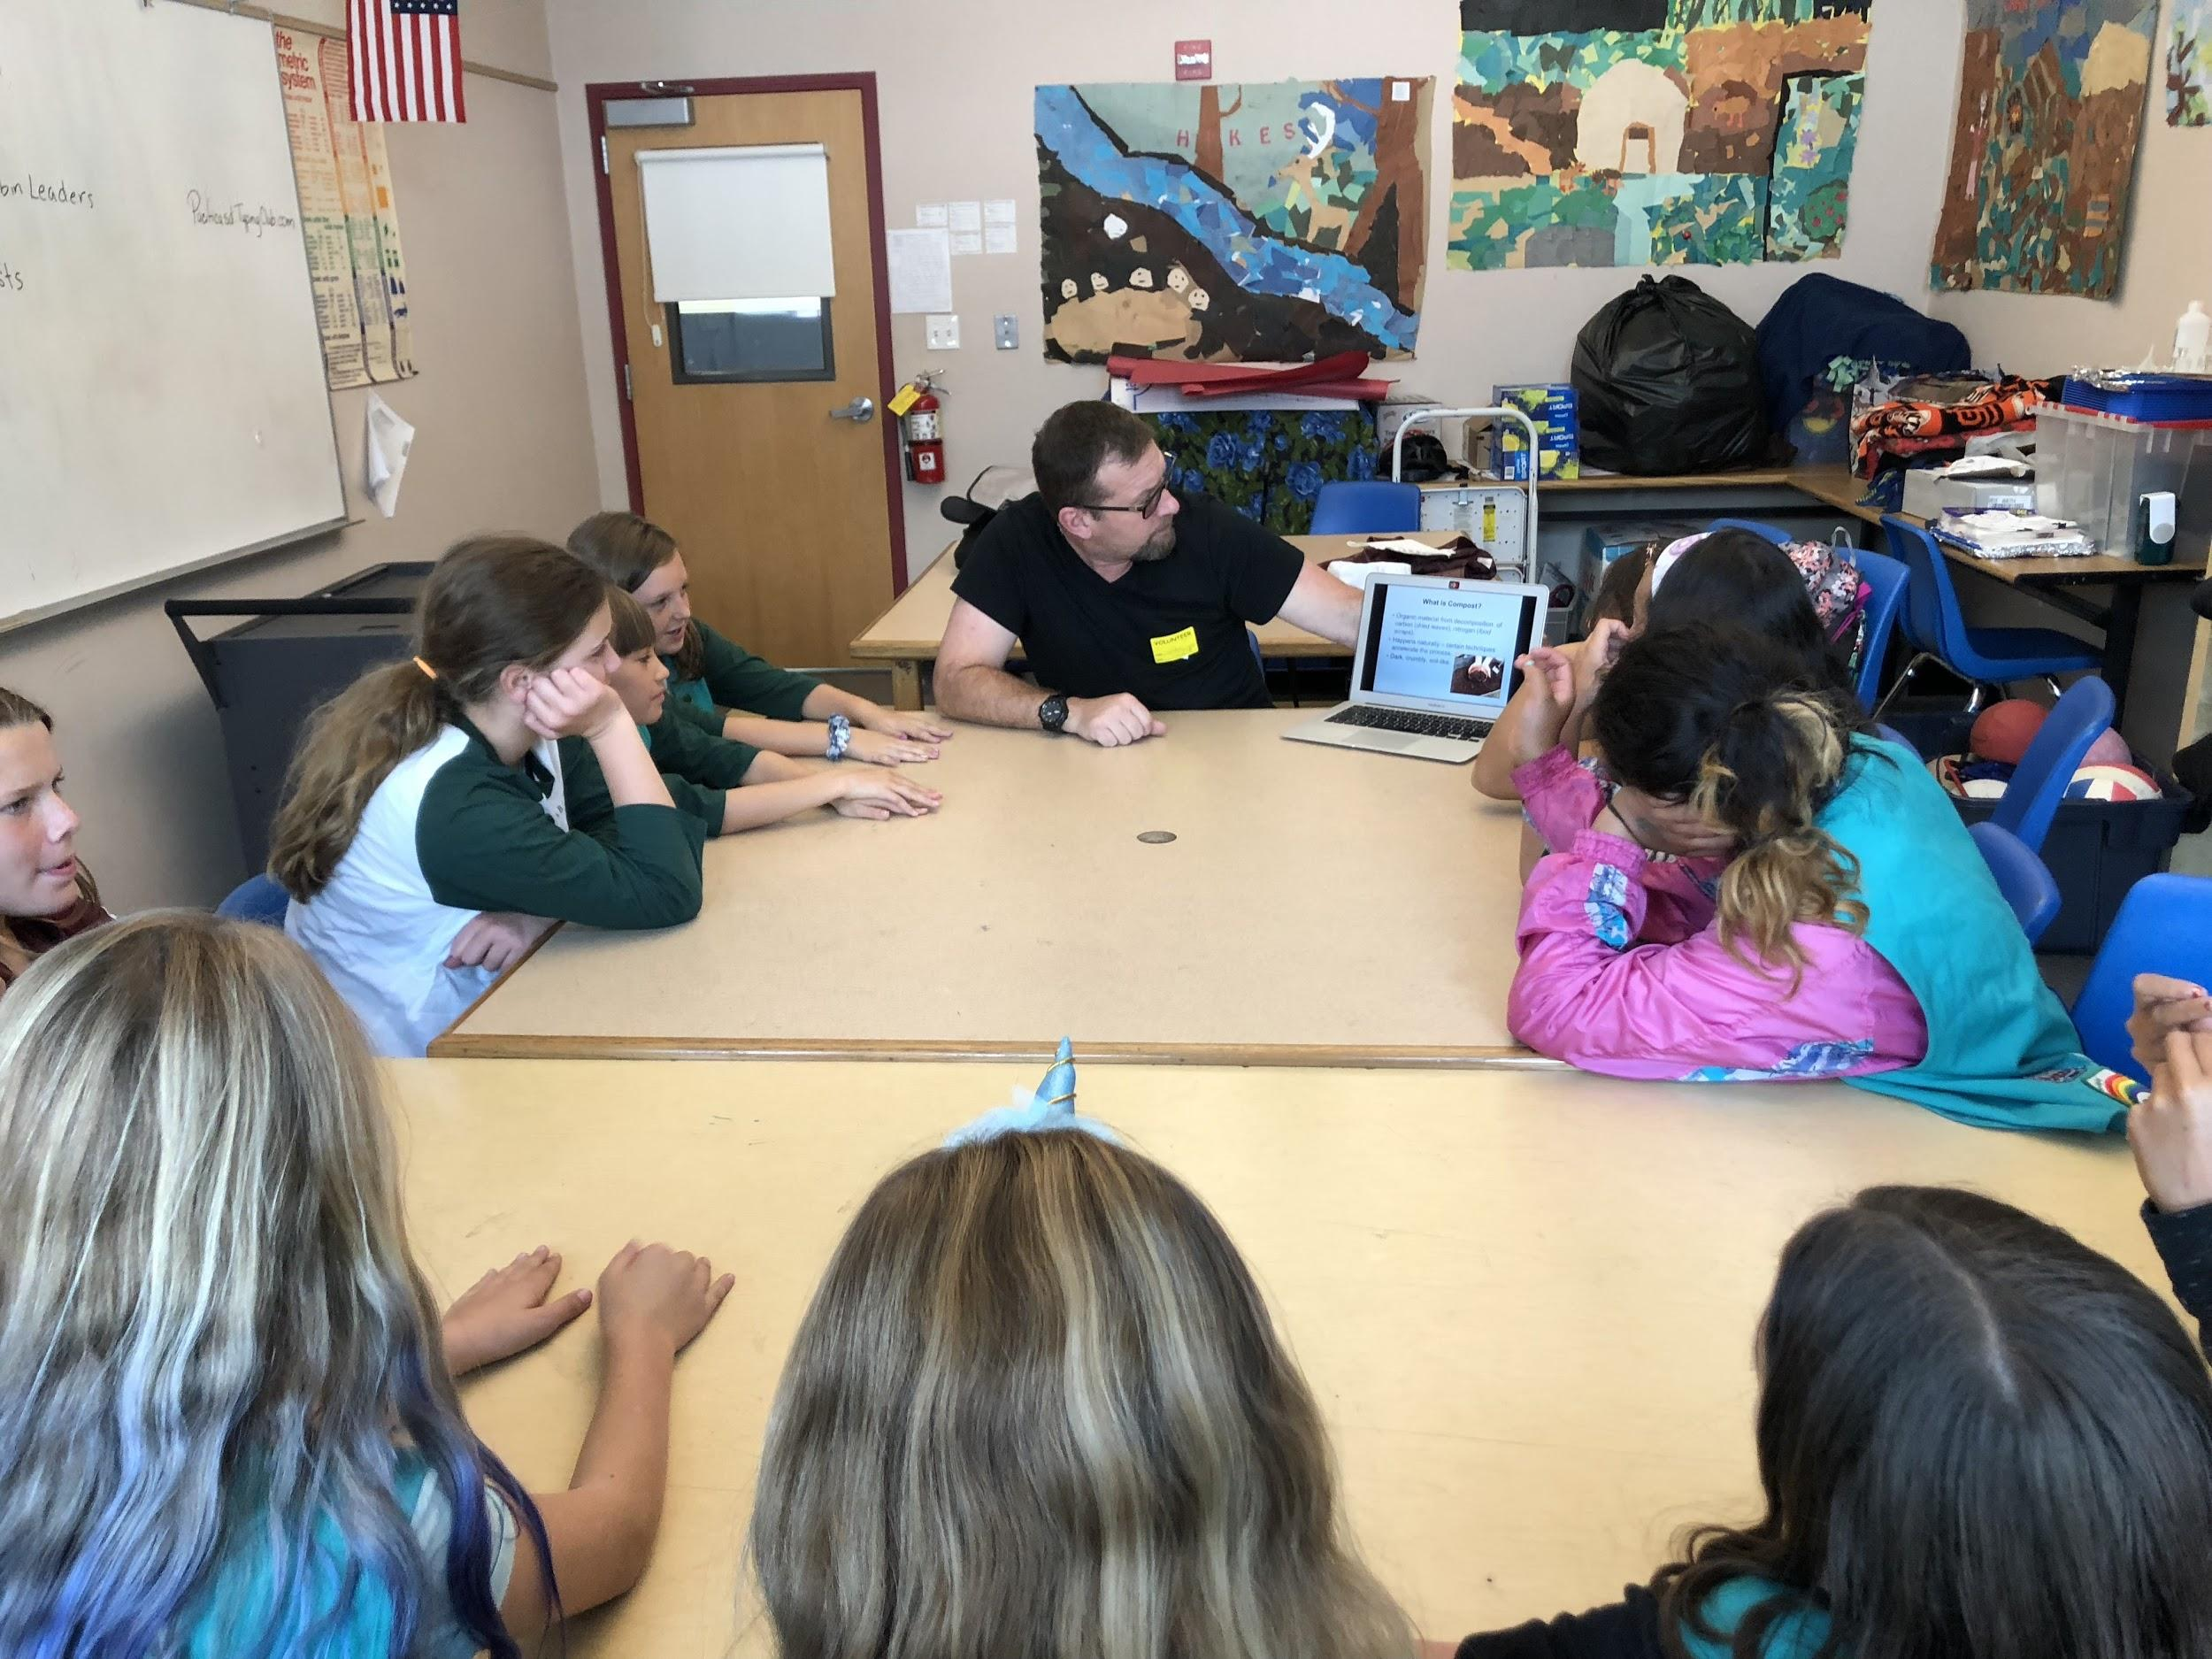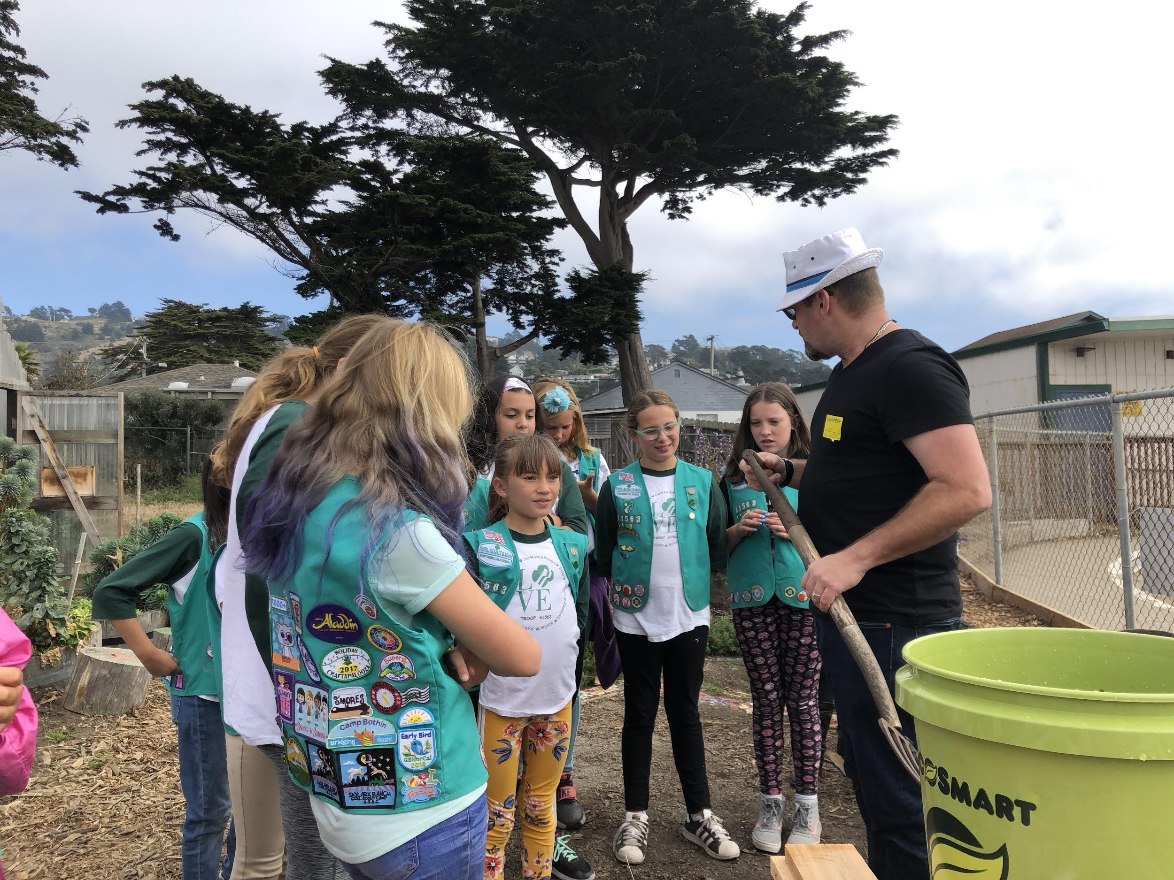
Compost Education with Shawn Haile.
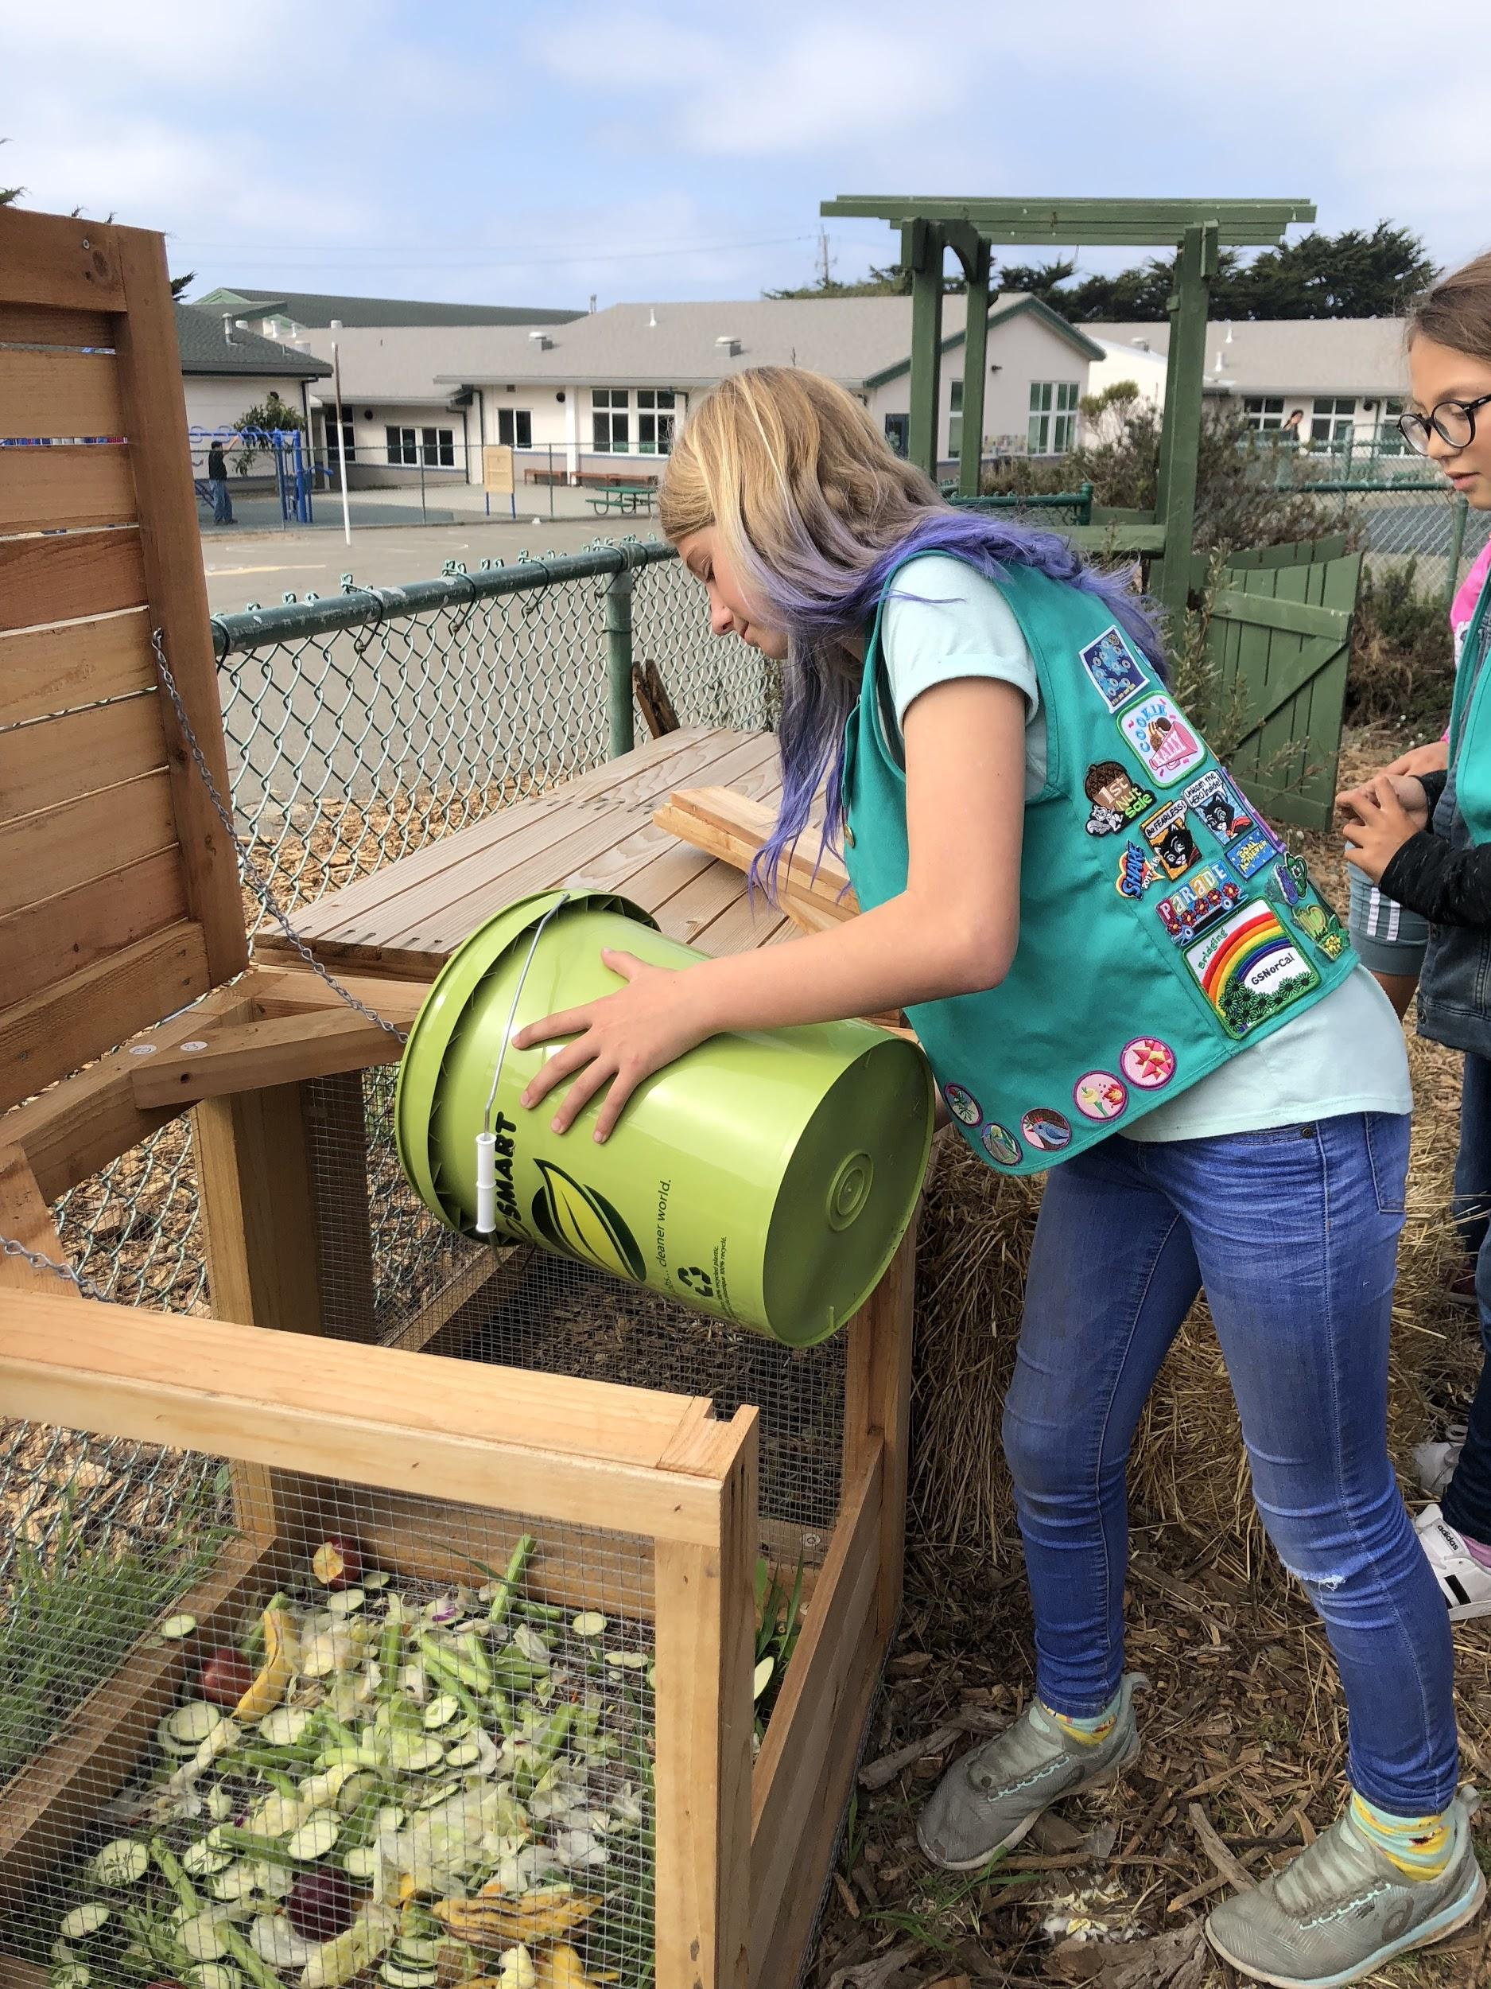
Depositing the first bucket.

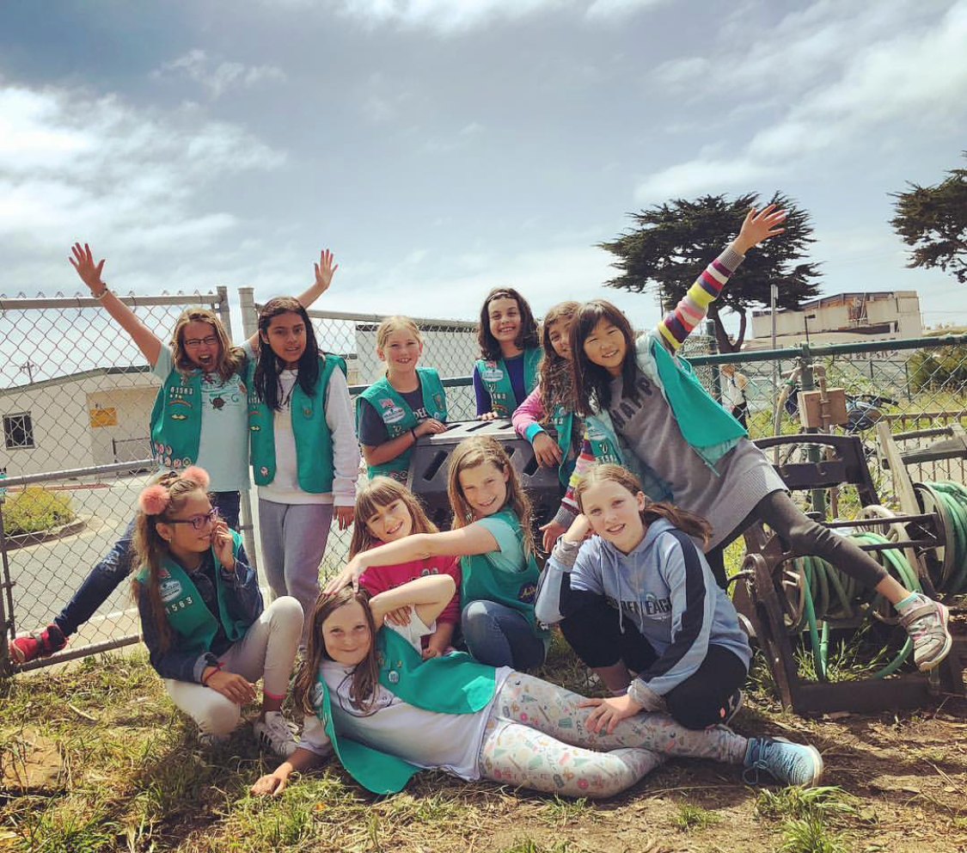
Green Team.

Winter/Spring 2019

By January 2019, the compost collection program was running on kid power (without adult supervision). And the scouts began training all of the OSS fourth and fifth graders to assist with collection. In April 2019 (when this training is complete), they hope to increase collection frequency (from 3 to five days per week).

In February, the program had its first bin of fully decomposed material, and the scouts are discussing how to use it in the garden.

In March, the Food Sharing program was approved to start at OSS.

